DEPENDENT VISA APPLICATION-STANDARD OPERATING PROCEDURE

Document Control
Document No. | SOP-DV-001
Version | 1.0
Department | Migration Services
Effective Date | ________________
Approved By | ________________

Purpose
The purpose of this Standard Operating Procedure (SOP) is to establish a consistent and efficient process for preparing and lodging dependent visa applications. This procedure ensures that:
- All required information and supporting documents are collected accurately.
- Applications comply with the requirements of the Australian Department of Home Affairs.
- Responsibilities of consultants and Registered Migration Agents (RMAs) are clearly defined.
- Clients receive timely updates and professional service throughout the application process.
- Errors, omissions, and processing delays are minimized through quality assurance procedures.

Scope
This SOP applies to all dependent visa applications processed by the migration practice, including but not limited to dependents applying under:
- Student Visa (Subclass 500)
- Temporary Graduate Visa (Subclass 485)
- Skills in Demand Visa (Subclass 482)
- Training Visa (Subclass 407)
- Skilled Visas (Subclass 189, 190 and 491)
- Employer Sponsored Visas
- Other temporary and permanent visas that permit the inclusion or addition of dependent family members.
This procedure applies from the initial client enquiry through to visa grant or application finalisation.

3. Roles and Responsibilities

3.1 Registered Migration Agent
- Final checking of documents
- LODGING THE VISA
- ENSURING THAT THE APPLICATION IS FINAL CHECKED

3.2 Consultant
- DISCUSSING THE APPLICATION O THE CLIENT
- PROVIDING THE SERVICE AGREEMENT AND REQUIREMENTS TO CLIENT
- INVOICING
- DOCUMENT GATHERING
- SENDING APPLICATIO FOR FINALZATION AND LODGING TO MIGRATION AGENT
- FOLLIWING UP AND ANSWERING CLIENT FOLLOW UP CONCERNS

4.Tools and Systems
The following systems and resources are used throughout the dependent visa application process.

Client Management
- Client Enquiry Form
- Client Information Sheet
- Client Engagement Log
- Client Relationship Management (CRM) System
- Internal Document Checklist

Migration Systems
- ImmiAccount
- VEVO (where applicable)
- Department of Home Affairs website
- Australian legislation and policy library

Document Storage
- Secure Cloud Storage
- Client Folder Structure
- Internal Quality Control Checklist

Communication
- Microsoft Outlook
- Microsoft Teams
- Microsoft Word
- Microsoft Excel
- Adobe Acrobat PDF

5. Document Management

Every client must be registered in the Client Engagement Log to generate a Unique Client Code

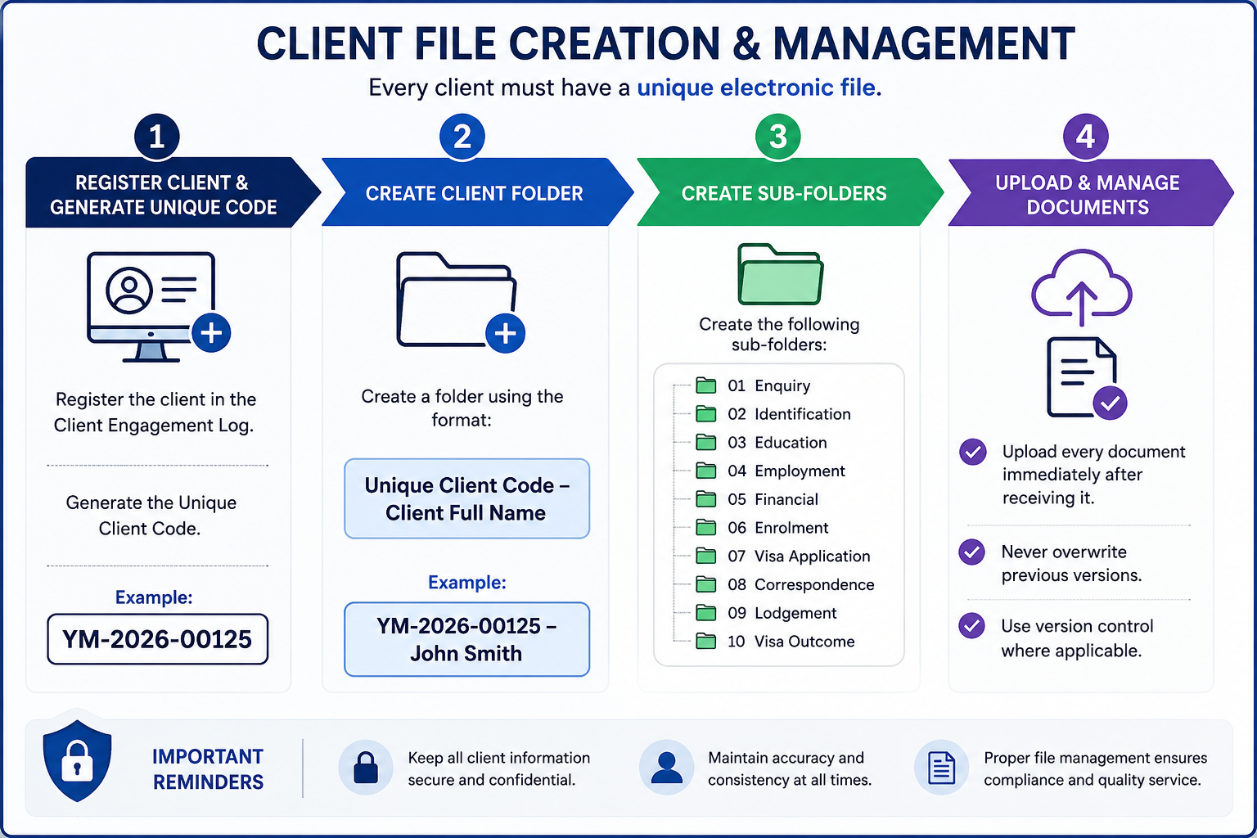

Step | Process | Procedure
1 | Register Client | Register the client in the Client Engagement Log and generate a Unique Client Code.  Example: YM-2026-00125
2 | Create Client Folder | Create a client folder using the following naming convention:  Unique Client Code – Client Full Name  Example: YM-2026-00125 – John Smith
3 | Create Sub-Folders | Create the following folders within the client's main folder:  01. Enquiry  02. Identification  03. Education  04. Employment  05. Financial  06. Enrolment  07. Visa Application  08. Correspondence  09. Lodgment  10. Visa Outcome
4 | Upload & Maintain Documents | Upload all client documents immediately upon receipt.  • Do not overwrite previous versions.  • Apply version control where necessary.  • Ensure all documents are saved in the correct sub-folder.

6. Dependent visa Application Procedure

Step | Responsible Person | Process
1 | Consultant | Receive enquiry and conduct initial consultation
2 | Consultant | Assess basic eligibility of dependent
3 | Consultant | Provide Service Agreement and quotation
4 | Client | Sign agreement and make payment
5 | Consultant | Register client in CRM and create client folder
6 | Consultant | Issue document checklist and Client Information Sheet
7 | Client | Submit required documents
8 | Consultant | Review documents for completeness
9 | Consultant | Prepare application package
10 | Registered Migration Agent | Review application and request amendments if required
11 | Consultant | Finalize outstanding documents
12 | Registered Migration Agent | Complete final review and lodge application
13 | Consultant | Send acknowledgement letter to client
14 | Consultant | Monitor application and upload additional documents if requested
15 | Registered Migration Agent | Respond to Department requests
16 | Consultant | Notify client of visa outcome
17 | Consultant | Archive file and update CRM

7. Quality Control Checklist
The Registered Migration Agent must complete the following quality assurance checks before lodging any Dependent Visa application. No application is to be lodged until all applicable items have been reviewed and confirmed.
Quality Check | Completed (✓)
- Principal visa holder's visa status has been verified and confirmed as eligible to include or sponsor a dependent. | ☐
- Relationship between the principal applicant and dependent has been assessed and verified. | ☐
- Identity of all applicants has been verified using valid passports or government-issued identification. | ☐
- Passports are valid for the intended visa application period. | ☐
- Marriage Certificate, Birth Certificate or other relationship documents have been reviewed and verified. | ☐
- Evidence of a genuine and continuing relationship has been reviewed (where applicable). | ☐
- Documents relating to dependent children, including birth certificates, custody or consent documents (where applicable), have been reviewed. | ☐
- Health insurance requirements (OSHC, OVHC or other applicable cover) have been confirmed. | ☐
- Health examination requirements have been confirmed or completed where required. | ☐
- Police Clearance Certificates have been obtained where required. | ☐
- All supporting documents have been reviewed for completeness, accuracy and consistency. | ☐
- All non-English documents have been translated by an accredited translator where required. | ☐
- Information is consistent across all application forms, declarations and supporting documents. | ☐
- All required forms, declarations and consent documents have been completed and signed. | ☐
- Government fees, professional fees and any applicable third-party costs have been confirmed with the client. | ☐
- All supporting documents have been correctly named, organized and saved in accordance with the Document Management Procedure. | ☐
- The client has reviewed and approved the final application prior to lodgment. | ☐
- The Registered Migration Agent has completed the final compliance review and approved the application for lodgment. | ☐
- The visa application has been successfully lodged through ImmiAccount. | ☐
- Transaction Reference Number (TRN), lodgment acknowledgement and all post-lodgment records have been saved in the client file. | ☐

Important
- Any missing, inconsistent or incomplete information must be resolved before lodging the application.
- The Registered Migration Agent must verify that the dependent meets the eligibility requirements under the relevant visa subclass and that the principal visa holder is eligible to include or sponsor the dependent.
- Any Request for Further Information (Section 56) issued by the Department of Home Affairs must be actioned before the specified due date.
- The Registered Migration Agent is responsible for ensuring that the application complies with the Migration Act 1958, the Migration Regulations 1994, current Department of Home Affairs policy, and the Migration Agents Code of Conduct before lodgment.

8. Compliance and Disclosure
Yale Migration is committed to maintaining the highest standards of professionalism, ethical conduct and compliance with Australian migration legislation.
All staff involved in Graduate Visa applications must comply with the following requirements:

Legislative Compliance
- Comply with all applicable Australian migration legislation, regulations and policy requirements.
- Follow all requirements of the Department of Home Affairs when preparing and lodging visa applications.
- Ensure that all information provided in a visa application is accurate, truthful and supported by appropriate evidence.

Professional Responsibilities
- Only a Registered Migration Agent may provide migration advice or make legal representations regarding visa matters.
- Consultants and administrative staff must not provide migration advice unless authorised to do so.
- Any complex migration issues must be referred to the Registered Migration Agent.

Client Confidentiality
- Protect all client information in accordance with Australian privacy requirements and the agency's privacy policy.
- Client information must only be accessed by authorized staff for legitimate business purposes.
- Client documents must be stored securely within the agency's approved document management system.

Accuracy and Record Management
- Maintain complete, accurate and up-to-date client records always.
- Record all client communications, advice provided, and documents received or submitted.
- Ensure all electronic files follow the agency's document naming and filing procedures.

Fee Disclosure
Before commencing any work, the client must receive clear written information regarding:
- Professional service fees.
- Government Visa Application Charges (VAC).

Client Acknowledgement
Before visa lodgment, the client must acknowledge that:
- All information provided is true, complete and accurate.
- They have reviewed and approved the final visa application.
- They understand their obligations as a Student Visa holder.
- They understand that providing false or misleading information may result in visa refusal or cancellation.

Visa Outcome Disclaimer
Yale Migration will prepare and manage every application with due skill, care and diligence. However, the approval or refusal of any visa application is solely at the discretion of the Department of Home Affairs.
Neither Yale Migration nor the Registered Migration Agent can guarantee the grant of a visa, as each application is assessed on its individual merits and in accordance with Australian migration legislation and policy.

